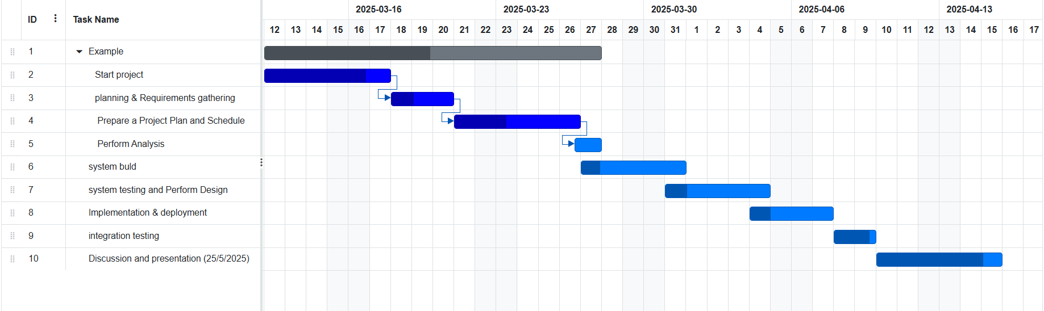**Gantt chart**

A Gantt chart is a project management tool that visually represents a project's timeline, displaying the tasks or activities against time. It is typically used to plan, coordinate, and track specific tasks and their dependencies throughout the lifecycle of a project. Each task is represented by a horizontal bar, where the length and position of the bar indicate the start date, duration, and end date of the task. Gantt charts allow project managers to assess the progress of tasks, identify potential delays, and optimize resource allocation. By showing task dependencies, they provide a clear overview of how each task is interconnected and how the completion of one task or more may affect subsequent activities. This makes Gantt charts essential for managing complex projects with multiple activities and deadlines.